## Jewish Family Services | Food Pantry Delivery

* *Org mission:*
  + Jewish Family Services (JFS) supports and strengthens lives throughout Greater Kansas City. We provide essential human services for people of all faiths, ages, cultures, and identities who are facing challenges in everyday life or times of crisis.
* *Project need:* 
  + Overview: An efficient and easy-to-use delivery/routing tool to get food to homebound clients twice monthly.
  + Real-time automated routing is key
  + Need to be able to add and remove clients from delivery list
  + Need to be able to update routes quickly if a volunteer calls in, or client doesn’t need an order that week.
  + Need to be able to determine capacity for delivery clients by being able to see a transparent view of routes
    - Clarification: capacity for deliveries to make sure it’s more efficient
  + Need a tool that is easy enough that multiple staff can manage it, can be delegated and parcelled out.
  + Need to be able to capture client info, volunteer info, food orders, alter routes.
  + Nice to have is for the delivery/route tool to integrate with the volunteer tool
  + Requirement: cybersecure for HIPAA
* *Scenario/workflow:*
  + Twice a month, their food pantry does deliveries to homebound clients (around 50-60 in total). A-G clients are one week, H-S clients are another week. 2nd and 4th Thursday of every month. Can vary some if there’s a holiday. 2nd Thursday is typically MO homebound clients. 4th Thursday is KS clients.
  + A volunteer calls the client a couple weeks ahead of time to take all the client orders. Phone calls are currently the best way to contact them. They do it two weeks out so that they have time to prepare the delivery.
  + The volunteer uses [**this Excel**](https://docs.google.com/spreadsheets/d/1c0PfgdJRwB8B-M7aw0fydf5zhOv9EQKx/edit?usp=sharing&ouid=115935028569429718698&rtpof=true&sd=true) form to track what items the client wants and quantities. As well as notes. Not much really changes to the template of this form as they usually have a set inventory. They try to give the client as much choice as possible, but also volunteers have to be able to lift all the items. If the client can’t be reached to take their order, they’ll usually plan to deliver a standard box for them. Russian speaking clients are indicated in the order forms. Right now they just have a standard order form for them, because they don’t have a great way to connect with them every time.
  + Volunteer will send Excel back to Zach with the selections. It will include notes if they couldn’t get ahold of client, this client doesn’t need this anymore, client needs wellness check, client is on vacation, etc.
  + Then Zach prints off the order sheets. Those go onto boxes with labels and order sheets. They used to use a  [**label template**](https://docs.google.com/document/d/1VfhAdOKugQ_i_lL7GvyFpNTq96oN2QJS/edit?usp=sharing&ouid=115935028569429718698&rtpof=true&sd=true) - one label goes on box, hygiene bag, protein, etc. So that nothing gets lost. But have just been handwriting those now because the template is off.
  + Then another volunteer puts the boxes together based on the notes. Some boxes are based on their preference and some, like produce boxes, are standardized. Perishable boxes are put together last minute before delivery.
  + Zach goes into a [**different Excel**](https://docs.google.com/spreadsheets/d/1IMGE1LxUNA1ocipYnuyeGVtBFuCWh6-C/edit?usp=sharing&ouid=115935028569429718698&rtpof=true&sd=true) that shows client/box details for the routes and prints out the routes for the delivery drivers. Notes field can be something like “knock really loud” or “gate code”.
  + Zach prints out MapQuest directions for drivers.
  + Then if volunteer drivers call in, have to reconfigure routes.
  + Delivery drivers come in during a set 30 min window to pick up orders.
  + If deliveries go smooth and normal, no notification really happens. But if something comes up like someone has moved to a different unit in the complex or couldn’t be reached, then they’ll let Zach know.
  + Used to have 8 or 9 delivery routes, but couldn’t get enough volunteer drivers to get that many routes. So now about 7 or 8 routes. Usually stay under 4 or 5 clients per route. Because we tell volunteer drivers that route shouldn’t take longer than hour/hour and a half. Kansas routes are easier because they’re closer to the office. MO routes are less likely to get volunteers because they don’t want to go downtown because of safety and parking, etc.
  + JFS has a location in Brookside so not super far away, but deliveries are currently done out of Kansas. They’ve discussed possibly doing deliveries out of MO too.
* *Pain points:*
  + How time consuming and cumbersome it is to update delivery routes and add or remove clients. And as such, only one person in the org really knows it well and so they’ve paused adding more delivery clients so it’s kept them from serving more clients.
  + Their volunteer count can fluctuate and right now it’s tedious to update routes based on volunteer changes. And the volunteer system does not talk to his system.
  + Current routes aren’t necessarily the most efficient route, but they just grandfathered in existing routes and sort of piece it together based on that. If routes were more efficient, could possibly take on more clients.
  + If he has 8 routes but only has 7 volunteer drivers, would be nice to spit out a different route system that can easily be updated with existing volunteers. Right now, have to manually update routes or him or another staff have to take on a route.
* *Attempted/possible solutions:*
  + Have considered using AI for the routes, but Zach is not very familiar with it.
  + The person before him used RouteXL. He wasn’t familiar with it and it seemed complicated, spent an hour one day inputting addresses and it didn’t work with the free version.
  + They do holiday meal projects for Passover and such and used MapQuest for that, categorize by zipcode and work off that. Was easier for that because they had a lot of volunteer drivers at the time. MapQuest is useful to determine the most efficient routes.
  + Door Dash has a system where they could deliver their food for a discounted price, but haven’t pursued it. DD came to their national JFS conference to express interest in delivering food. Maybe like $10 a route. Would give DD the addresses and they can figure out route.
* *Project commitment:*
  + Zach leaves for paternity leave in early September. Definitely feels doable. Rachel from JFS said could also support and be a presence if unavailable.
* ***Dev notes:***
  + Rob thinks there is free routing software online that could suggest most efficient routes. AI might not do this as well.
  + Might be some that are easier to use than RouteXL.
  + If a dev could put an easy front-end onto an existing routing software, it could make it easier.
  + Possible API to link volunteer software with routing software.
* ***Team thoughts:***
  + Is there not a way to use AI to do this? (Leslie)
  + Dig into their volunteer tool more to understand how it works/what it captures.

**Discovery and Design Workshop 7/14/25**

**How Might We**

* Votes ranking (each got 2 votes):
  + 1. Real-time automated routing is key
    - Identify time it takes for the route to take
  + 2. Need to be able to add and remove clients from delivery list
  + 3. Need to be able to update routes quickly if a volunteer calls in, or client doesn’t need an order that week.
  + 4. Need to be able to determine capacity for delivery clients by being able to see a transparent view of routes
    - How can we grow this sustainably
* Nice(r) to have
  + 1. Need a tool that is easy enough that multiple staff can manage it, can be delegated and parcelled out.
  + 2. Need to be able to capture client info, volunteer info, food orders, alter routes.
    - Zach asking Hayden- can this be integrated into ETO? ETO is client database
      * Hayden: putting in client IDs might be able to integrate this tool. It would be nice to integrate notes taken for each client (e.g. wellness check, how to enter their home)
  + 3. Nice to have is for the delivery/route tool to integrate with the volunteer tool

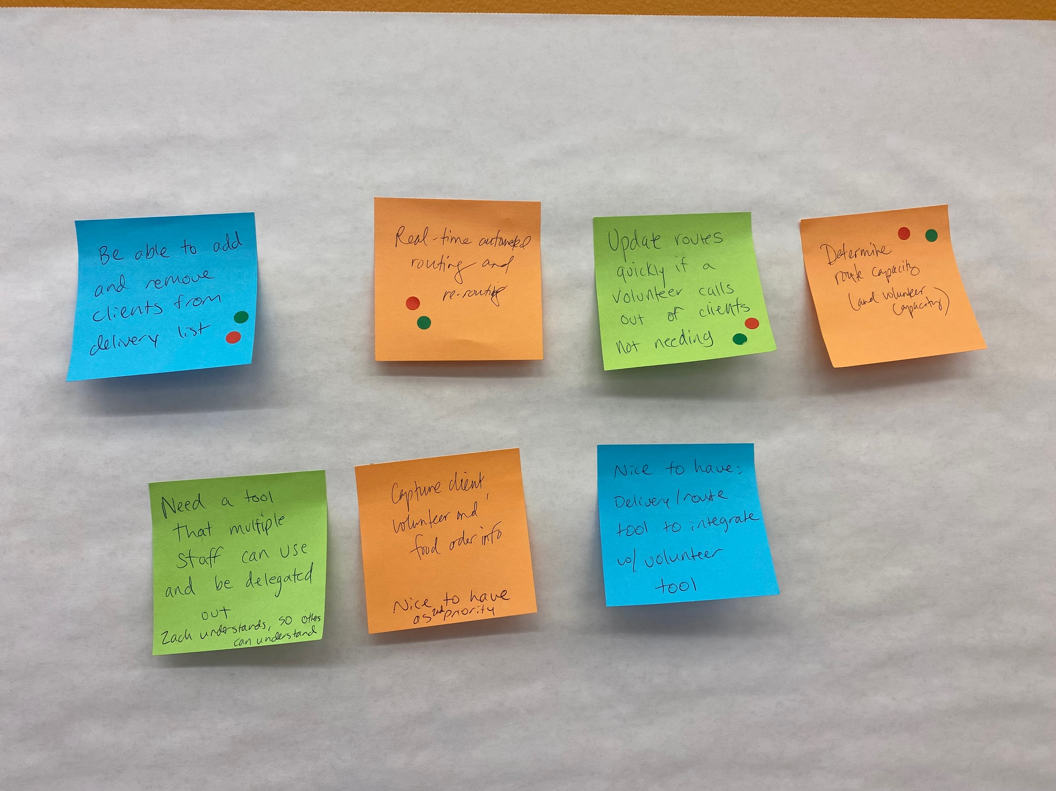

**User Journey**

Volunteer (Sonny) takes client’s orders and puts it into an Excel spreadsheet, then sends to Zach. Then starting user journey from there.

Step 1: Identify who will be receiving the delivery on specified date (second and fourth thursday of the month)

* Who: JFS staff
* When/Where: Zach receives list of orders a week before the deliveries (first and third week of the month)
* Needs:
  + Zach - they’d need client IDs so they can easily select the client and know their needs
  + Zach needs to be flexible to modify routes based on # volunteers
* Notes:
  + Process: Consult with volunteer team to see how many volunteers they have for a particular day, then depending on # volunteers, they would divide the routes a certain way, then volunteer team let’s him know # volunteers 1-2 days before delivery day

Step 2: Identify # volunteer drivers

* Who: JFS staff
* When/Where: 2 days before
* Needs: be able to adjust on the fly
* Notes:
  + Try not to make routes longer than 1.5 hours, 6 max (especially if they’re all in the same apartment complex)
  + Want to identify minimum volunteer threshold (at least 4 delivery drivers? How to add people to different routes?)
  + Why do they want to cap it at 1.5 hours?
    - Zach - typically the same volunteer drivers, any longer and it becomes too much of a time constraint and it’s hard to recruit new people. Even 1.5 hours feels like a lot. The distance is also really important
    - They haven’t really taken new clients for about 2 years. Has been some turnover with people passing away, but been pretty consistent. Prioritize high need clients as staff recommends them.
  + Do they track where the volunteer lives?
    - Zach: this would be really helpful to have as a feature, higher priority than a nice to have. We’re asking a lot of volunteers and want to make the process as easy as possible for them to end close to home. This could help us recruit Missouri-based drivers (e.g. Grandview clients). Sometimes volunteers would tell them they have to be done at a certain time, or they have to go downtown at the end of the day and want to end there.
  + How do they assign volunteers to the specific routes?
    - Zach: assign volunteers that are familiar with certain routes, not necessarily what’s most convenient
    - Typically is assigned day-of, come around 1:45-2:30pm, they tell them what route they have and they give it to them. On occasion, someone will see their route and say that they no longer want this route (e.g. can’t go downtown), so Zach will switch their route on the fly.
      * Nice to have - volunteers that have preferences on places to go/avoid
      * If they did notify them ahead of time, they could either be appreciative, or say they don’t want that route.
    - Zach likes to make adjustments to routes day-of, and would like to make it quickly
    - Zach hasn’t “closed” routes at all except for when patients pass away
    - Print out looks like: addresses in sequential order
      * Zach has printed out maps for holiday deliveries, but volunteers typically don’t need the maps. Volunteers rarely have questions about where to go once they receive the routes. Volunteers onboarding recommends they use their phone for navigation.
      * Volunteers really like the paper printed out, volume is pretty low that printing is not hard to do
      * Nice to have: this platform could easily print out the route info
    - Process after the fact: volunteers pick up their routes, pick up the boxes and load them into their cars
    - Doordash opportunity: JFS Pittsburgh may be trying this out, where Doordash partners with them and does the food delivery process.
    - Zach question: don’t know of other organizations that do food deliveries
* 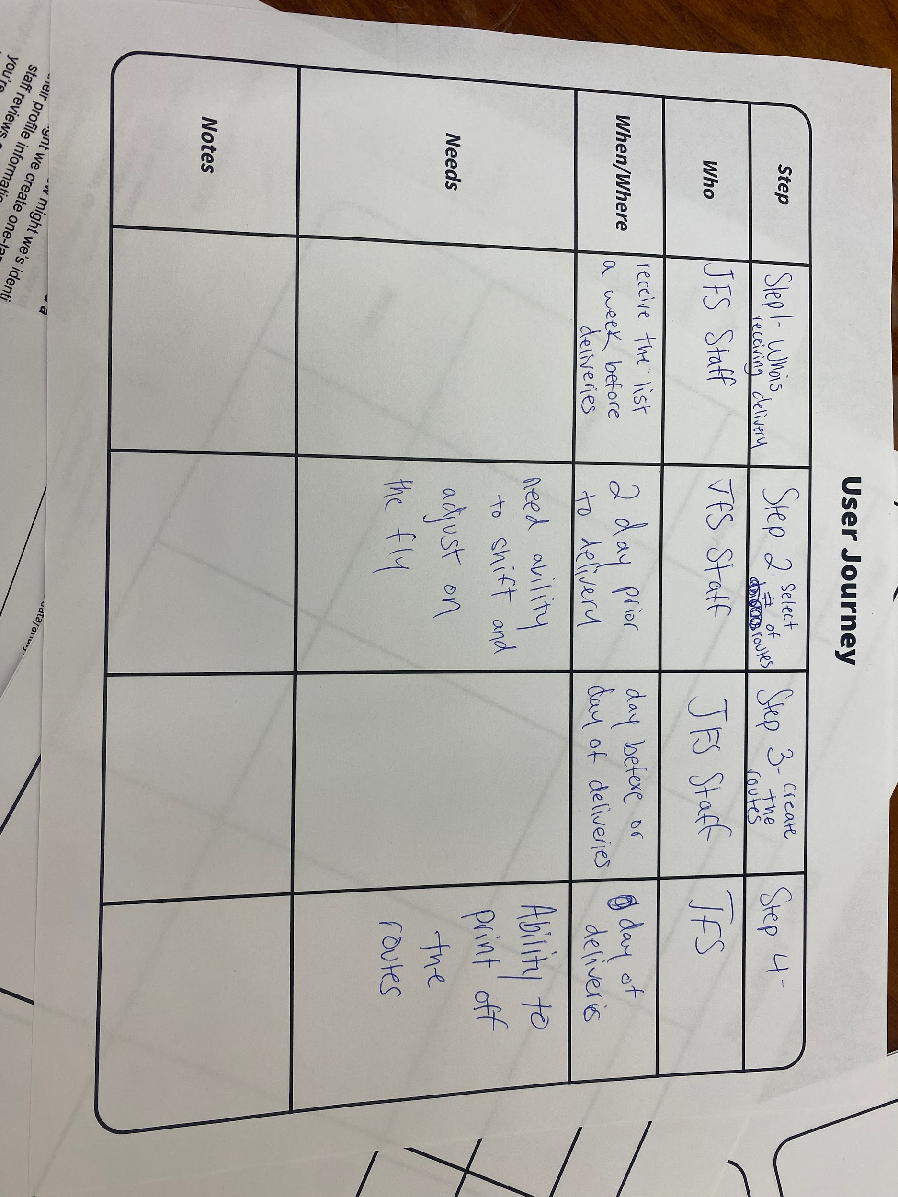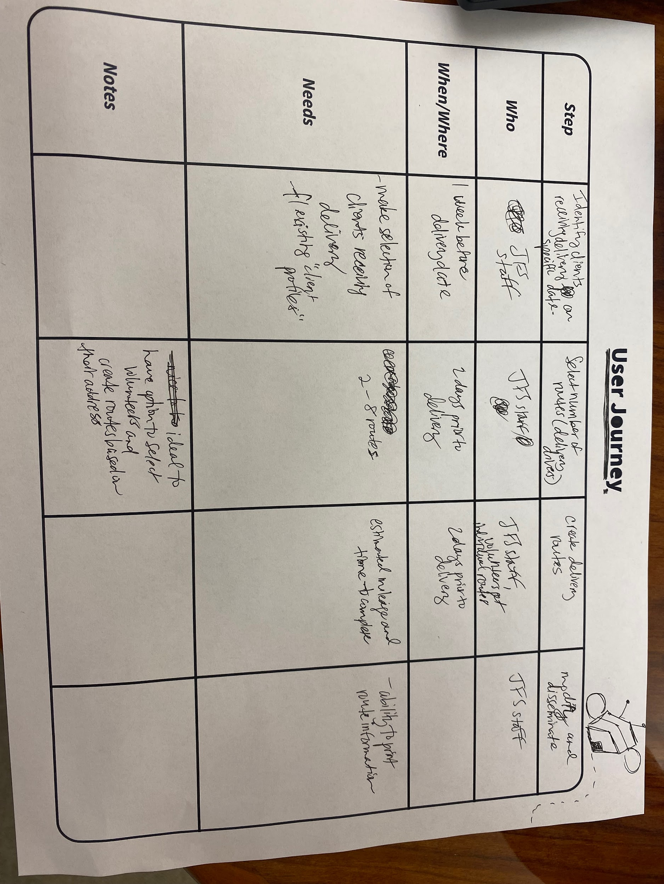

**Crazy 8s Activity**

Comments:

* Create volunteer profile - see their preferences and assign them based on what days they do deliveries
* Zach: nice to haves is that this tool identifies if they can expand/scale up their capacity to do more routes in the future
* Paper forms for volunteer drivers
  + Ideally one page, ideally larger font
  + Doesn’t necessarily need to have specific boxes/orders needed
  + Most important: addresses and phone numbers are accurate (e.g. client moves and the info isn’t updated
  + Nice to have: client database can have most accurate information/addresses and can automatically update the route information
  + Hayden is main person that updates EPO/databases

Voting:

* Hayden and Zach swapped pages and voted for top favorites
* Zach - Hayden’s ratings make sense

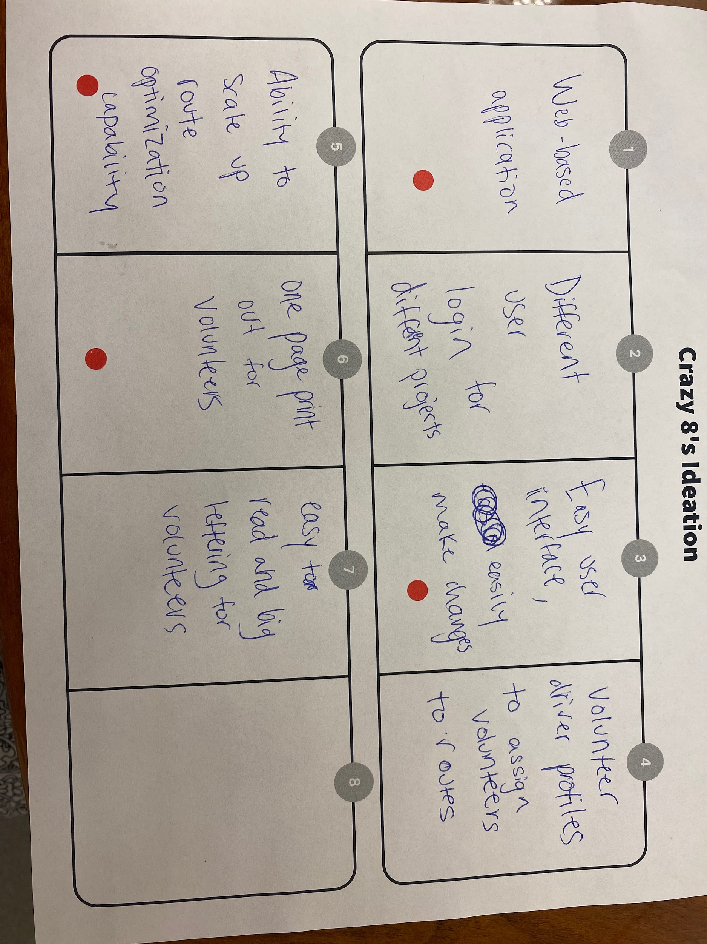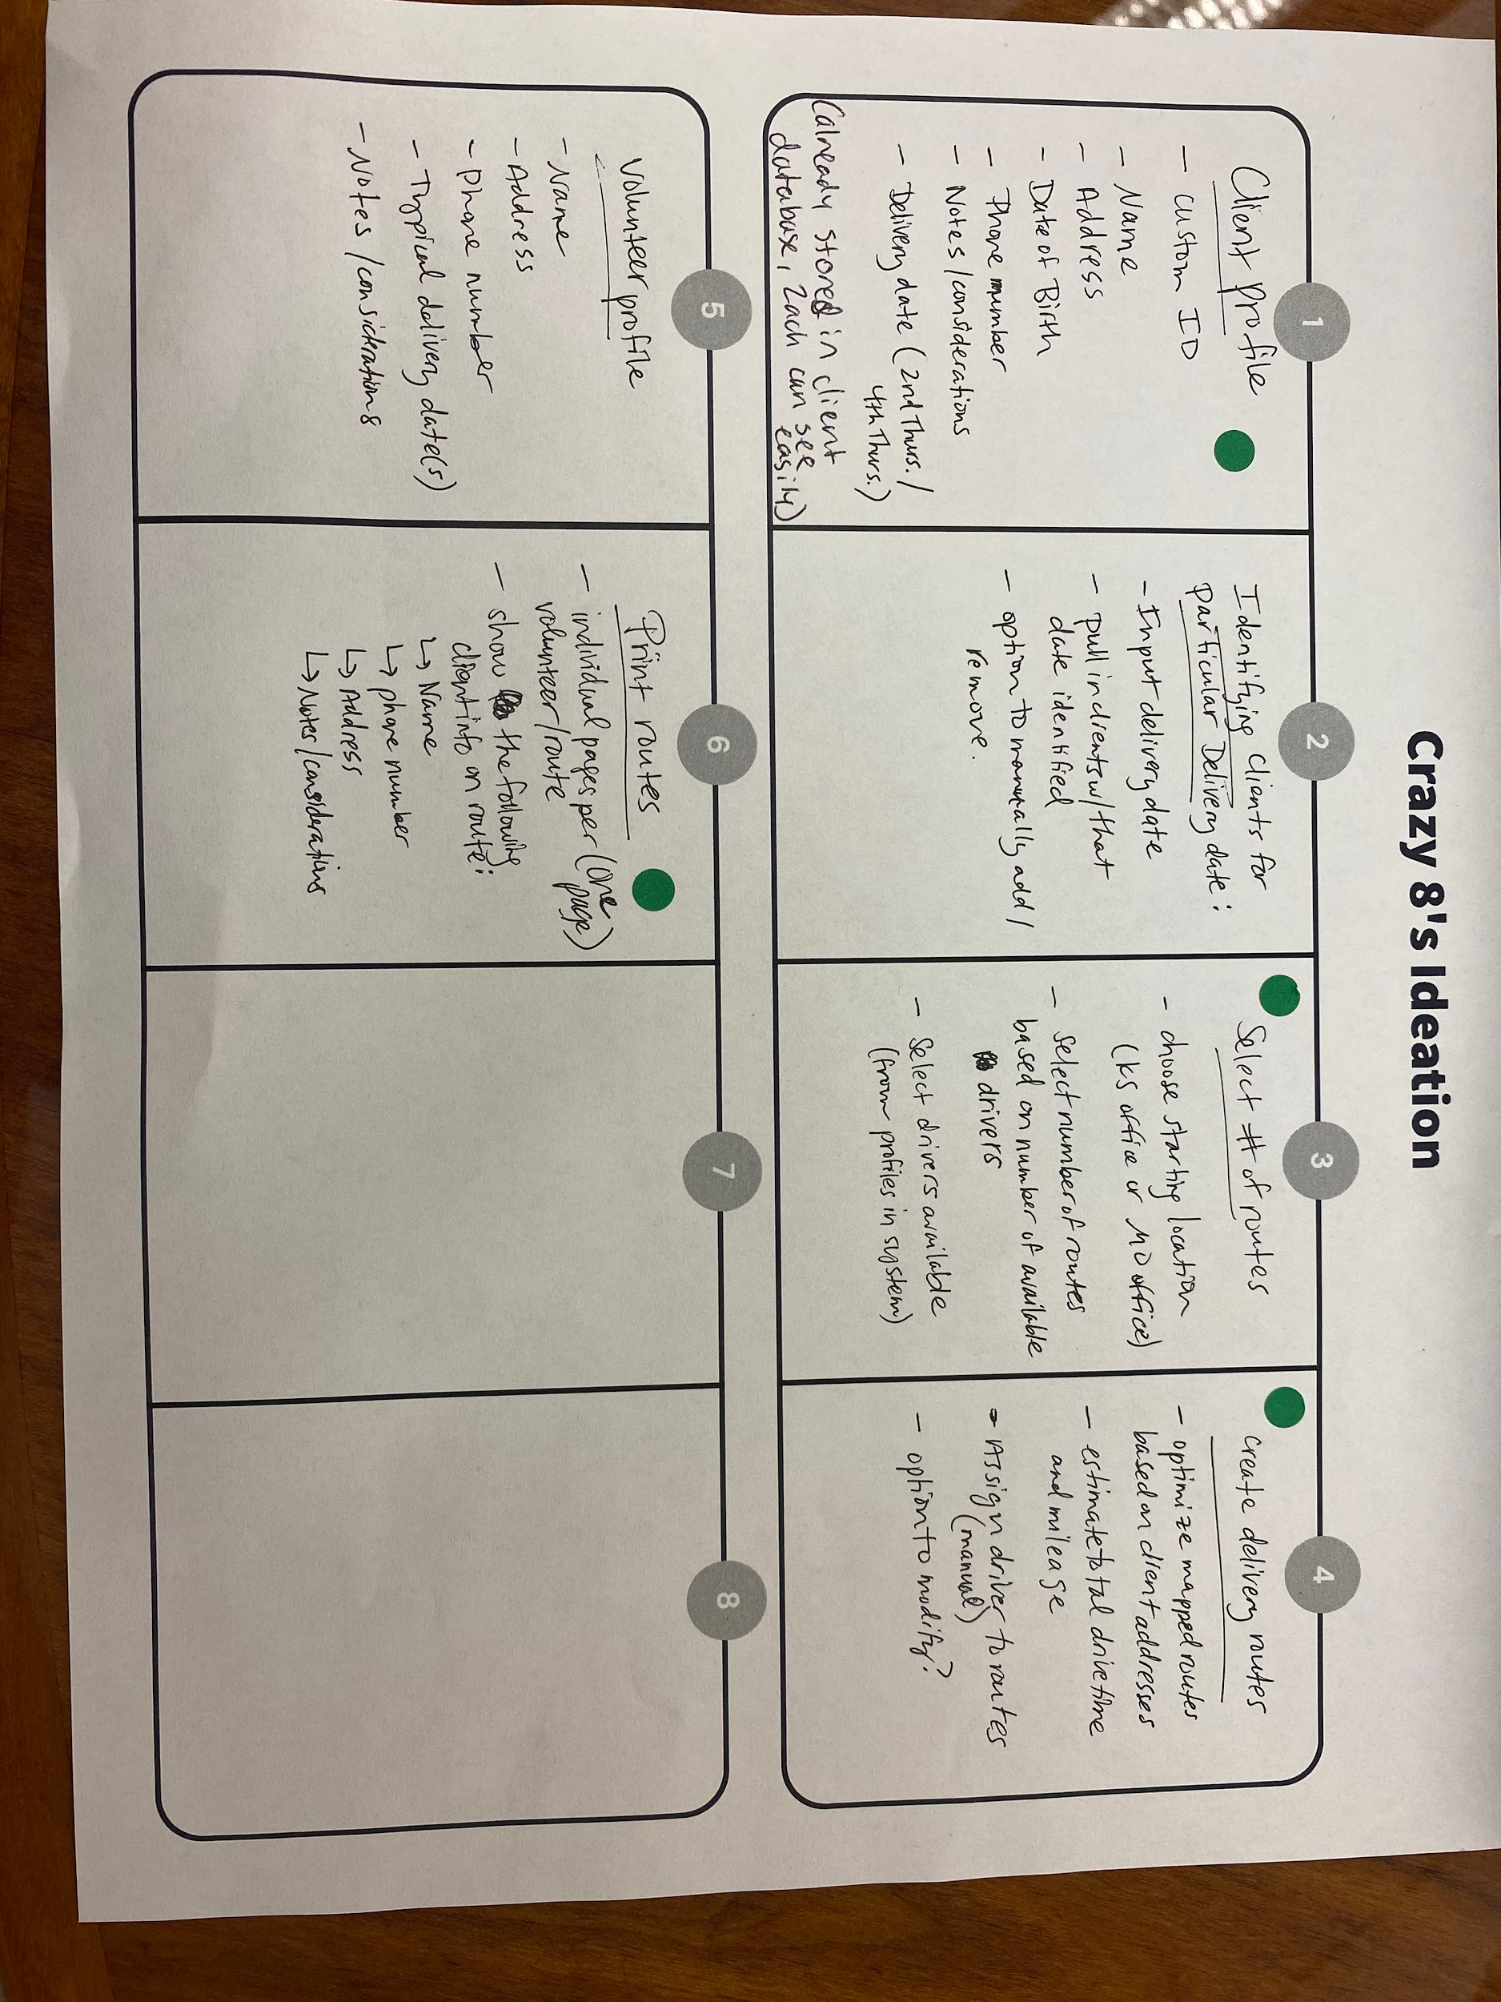

**Determine key needs/features**

System Set up:

* **Creating client profile**
* Information collected - custom ID, name, phone #, address, DOB, language spoken, delivery date (2nd or 4th thursday), any notes/considerations
* Zach receives volunteers and notate who is receiving orders
* **Volunteer profile**
  + Info collected: Name, address, phone #, notes/considerations/preferences

Step 1: Select clients for delivery date

* Filter by delivery group
  + Group 1: MO clients/2nd Thursday
  + Group 2: KS clients/4th Thursday
  + Group 3: Holiday
* List clients in that delivery group + have option to manually remove

Step 2: Select # routes based on # of drivers available

* Drop down range for # of routes

Step 3: Create delivery routes

* Optimize mapped routes based on client addresses
* Estimate route drive time and mileage
* Manually assign routes to volunteers
* Function: ability to save routes within the platform

Step 4: Print routes & distribute to volunteers

* Info to show on this printout: route name (A, B, C) client name, phone number, address, language, notes/directions

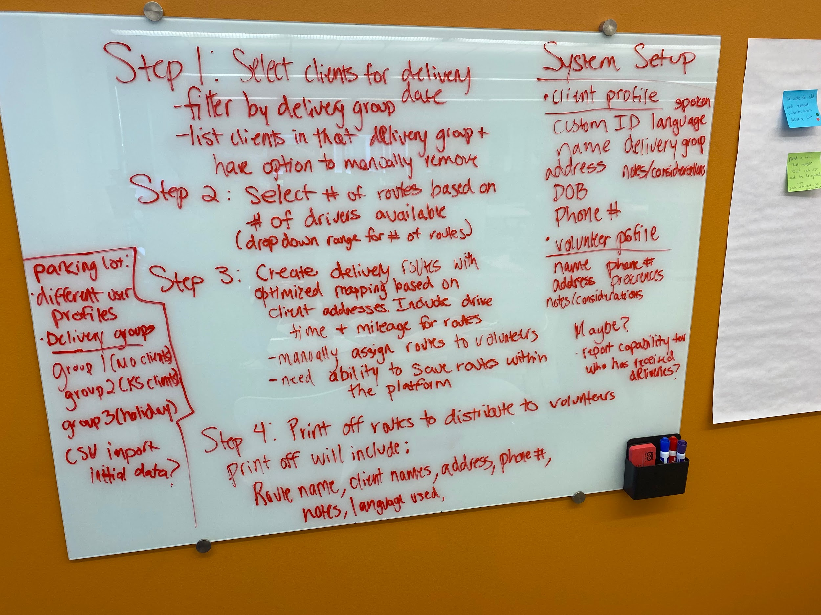

Wrapping Up

Hayden comment: **Reporting** -> currently use order form to track deliveries, since this tracks the weight of the food

* How does the volunteer team track deliveries?
* Maybe - think about report capabilities for who has received deliveries

**Parking lot/nice to have’s**

* Logging in with different user/staff profiles
* Delivery group separation (group 1, 2, 3)
* CSV import initial data?

**Questions:**

* What data would they want to work with at the hackathon?
  + Just addresses? Zip codes?
  + Do the coders sign any confidentiality contracts (HIPAA)? If not, that would determine what information they can give
* Should they give out volunteer information?
* After this is built, what will it cost JFS to continue hosting these platforms?
* Can this be designed so there is an easy way for the client/volunteer information to be easily imported via CSV?